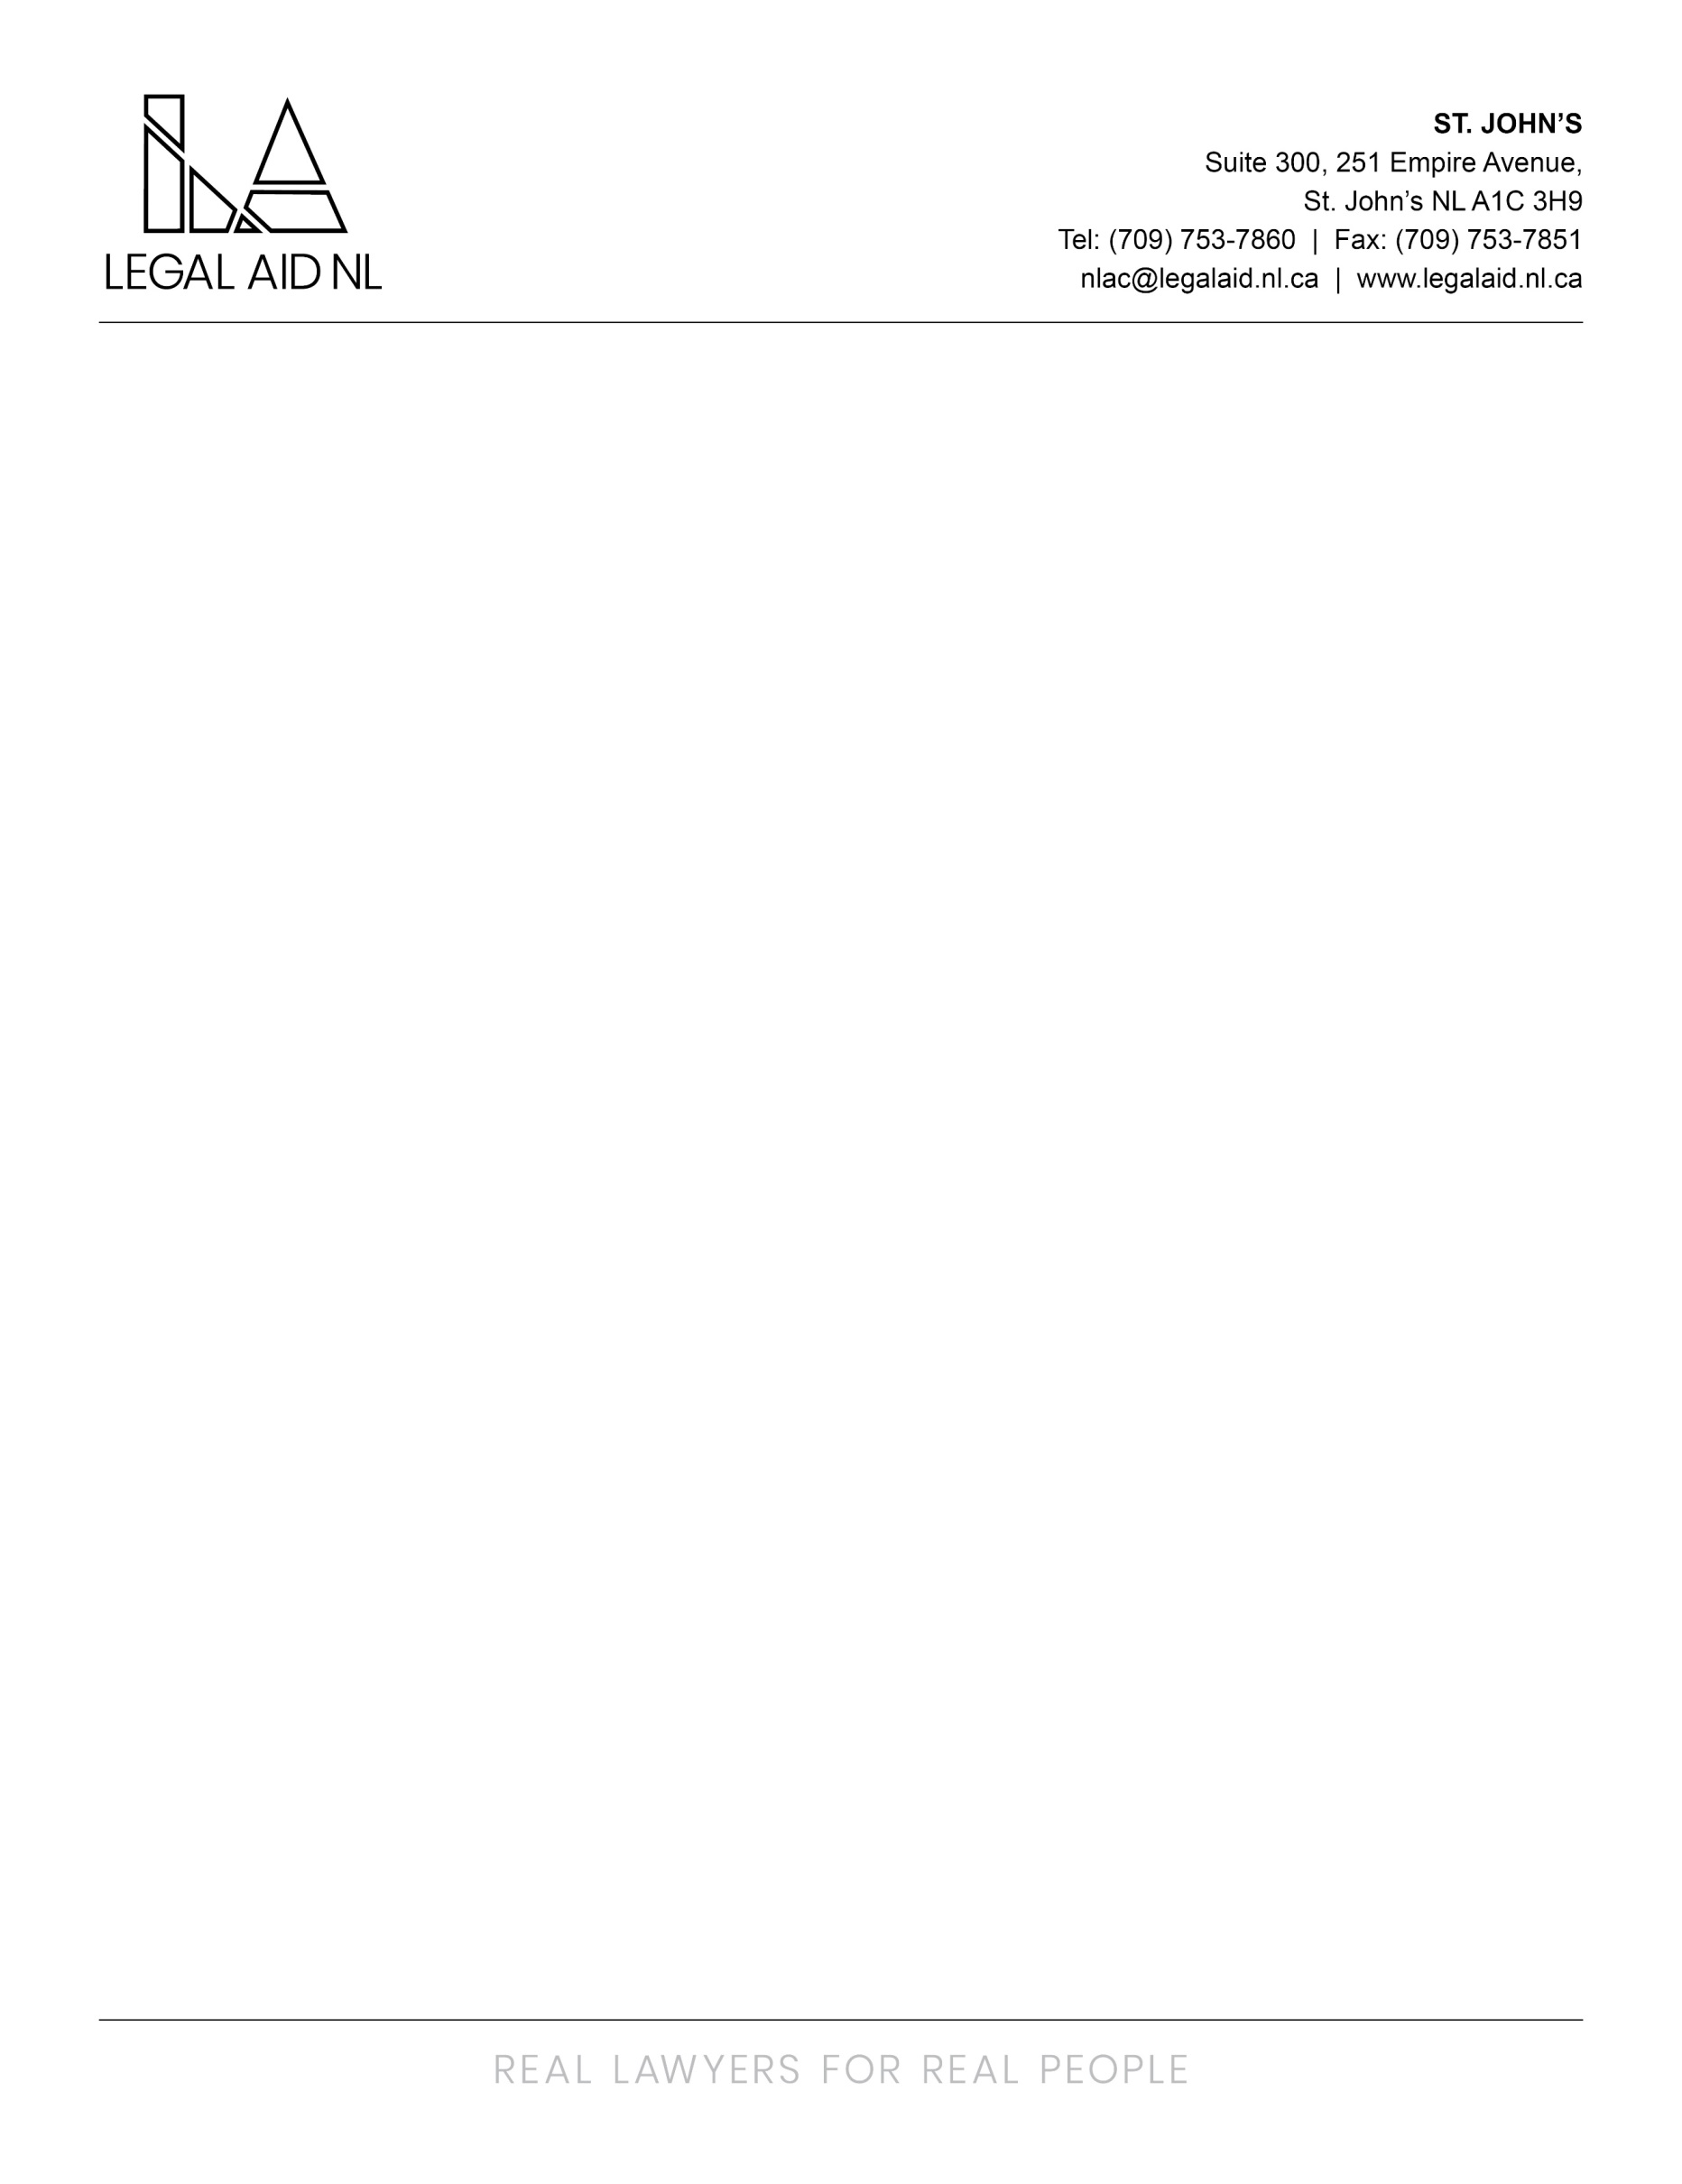

We are currently seeking an Area Director (Staff Solicitors and Legal Administrative Staff as direct reports) to fill an immediate vacancy in our Happy Valley-Goose Bay Area Office.

The successful candidate will act as delegate for the Provincial Director’s Office in the provision of Legal Aid Services within Happy Valley-Goose Bay while ensuring compliance with the Legal Aid Act, Regulations and the Policy Manual of the Commission.

The successful candidate will have a wide range of responsibilities including but not limited to:
- Responsibility for directing the development of staff solicitor resources and general assignment of staff solicitors
- Responsibility for the assignment of work and determination of work priorities for staff solicitors and legal administrative staff
- Providing mentorship and counselling to staff solicitors in various areas of law
- Providing oversight and direction to staff solicitors and legal administrative staff
- Acting as delegate of the Provincial Director in the delivery of Legal Aid Services in office area and ensures compliance with Legal Aid Act, Regulations and Policy Manual in relation to internal processes and procedures including but not limited to:
  - Requests for Change of Solicitor
  - Notices of Intention to Cancel
  - Deciding whether to grant requests for annual leave and preparation of short notice leave forms when required
  - Travel Authorizations
  - Travel claims
  - Court Call
  - Expense Authorizations
- Overseeing Intake process:
  - Making determinations and / or providing guidance to staff solicitors as to case merit
  - Making determinations as to financial eligibility including payment agreements
  - Ensuring that appointments are timely
- Maintaining Criminal Queue - case merits and file assignment
- Maintaining Case Assignment Queue - case merits and file assignment
- Assessing potential conflicts of interest
- Reviewing of staff solicitors monthly LAMIS reports and taking appropriate action:
  - Time Usage Analysis Report
  - Active Certificates Statistics Report
  - Pending Report
- Conducting Performance Reviews and/or Practice Reviews of staff solicitors and legal administrative staff
- Conducting/providing for staff solicitors mentoring and training as necessary
- Receipt and recording of first level Appeals and reassessment of decision when appropriate
- Assigning staff solicitors to office duties such as Duty Counsel and Office Counsel
- Addressing client complaints regarding staff solicitors
- Ensuring compliance with relevant legislation such as Access to Information and Protection of Privacy Act (ATIPPA) and Workplace Health Safety and Compensation Act (WHSCC)
- carrying out other initiatives and projects as may be required

The successful candidate will also have an active, though reduced, case load as a Staff Solicitor.

Candidates must hold a Law Degree from a recognized school of law, be members in good standing with the Law Society of Newfoundland and Labrador. Minimum 5 years’ at the bar is required with extensive experience in the areas of Family and Criminal Law. Candidates must have strong verbal and written communication skills, excellent organizational and interpersonal skills, and the ability to handle difficult situations and problem solve as needed. Exceptional accuracy and attention to detail is a must, along with a strong work ethic and the ability to take initiative. Additionally, candidates must possess a positive attitude, a passion for providing service and high standards of ethics, professionalism and confidentiality and a demonstrated ability to thrive in a fast paced and challenging legal environment. Experience in a managerial role would be considered an asset

The successful candidate will be required to provide a Certificate of Conduct with Vulnerable Sector Check prior to commencing employment.

Employees of the Newfoundland and Labrador Legal Aid Commission are covered under the Provincial Government’s Pension and Health Plan. Optional Dental and Disability Plans are also available.

The salary for this position is based on the Solicitor V Pay Scale ($141,490 to $186,762 annually) plus northern benefits.

Interested applicants must submit resume and cover letter to humanresources@legalaid.nl.ca by 4:00pm on Friday October 30th, 2026. Late expressions will not be considered. We thank all applicants for their interest, however, only those selected for an interview will be contacted.

