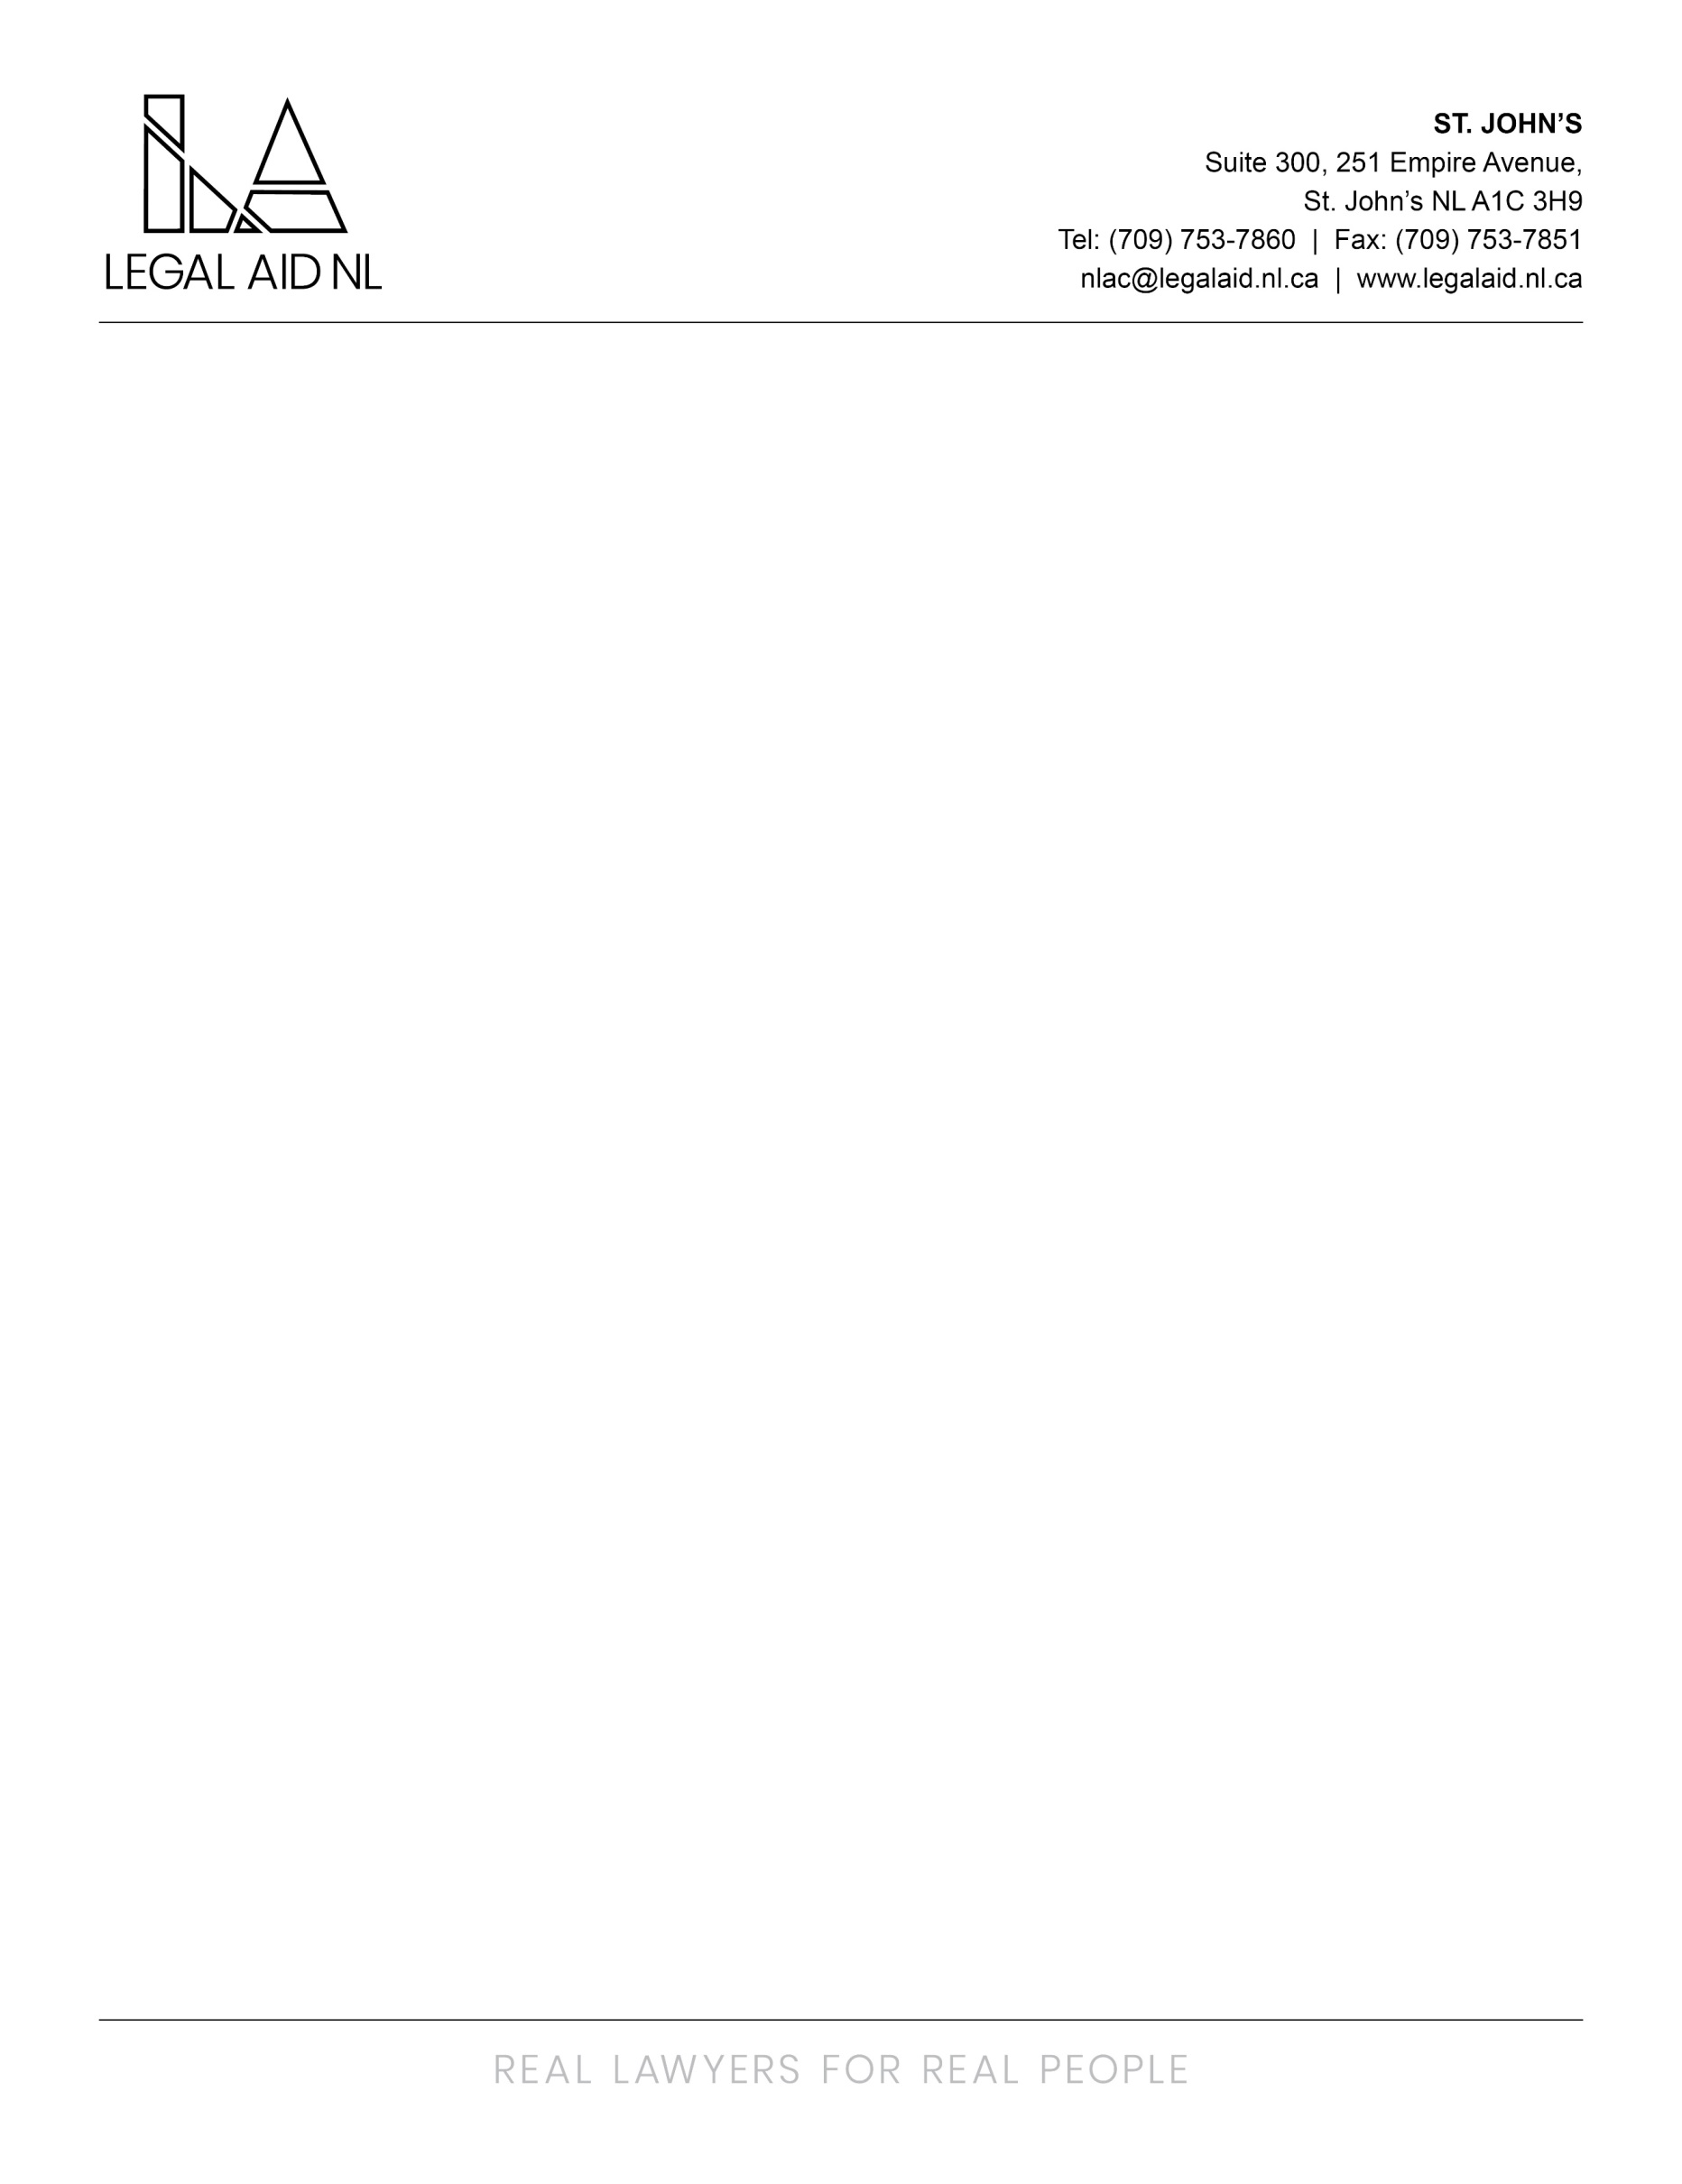

Legal Aid NL is an innovative legal aid plan that responds to the needs of low income persons by promoting access to justice through the provision of quality legal assistance for criminal, family and some administrative law matters. Services are provided through a staff based delivery model via the twelve full service offices and five project offices in the province.

We are searching for experienced Legal Assistants to fill a contractual position in our St. John’s Area Office (SJ1).

As a member of the team the successful candidate will be responsible for a variety of legal and administrative support functions, including but not limited to:

- Providing administrative support to assigned lawyers(s) legal practice by:
  - Preparing, reviewing and editing a wide range of legal documents, client applications and correspondence of a confidential nature
  - Managing all incoming/outgoing correspondence and phone calls in a confidential, organized and efficient manner
  - Establishing and maintaining lawyers calendars, including arranging meetings, travel and scheduling of reminders
  - Acting as a liaison between lawyers, clients, staff members and outside organizations
  - Creating and maintaining a filing system
- Assisting with knowledge sharing, mentoring and training of co-workers and new employees as requested

The successful candidate will hold a Legal/Administrative Assistant Diploma (or equivalent) or 3-5 years’ experience in a similar administrative role. In addition candidates must have strong verbal and written communication skills and the ability to handle difficult situations and problem solve as needed. Exceptional accuracy and attention to detail is a must, along with a strong work ethic and the ability to take initiative. Additionally, you possess a positive attitude and are passionate about providing above-average client service. A proficiency in Microsoft Office is required for this wrole.

The successful candidate will be required to provide a Certificate of Conduct with Vulnerable Sector Check prior to commencing employment.

Employees of the Newfoundland and Labrador Legal Aid Commission are covered under the Provincial Government’s Pension and Health Plan. Optional Dental and Disability Plans are also available. The salary range for this position is $46,373.60 to $51,287.60 per annum.

Interested applicants should send resume to humanresources@legalaid.nl.ca no later than 4pm on Friday October 30th, 2026.

We thank all applicants for their interest; however, only those selected for an interview will be contacted. Applications may be used to fill similar positions posted within 6 months of closing.

