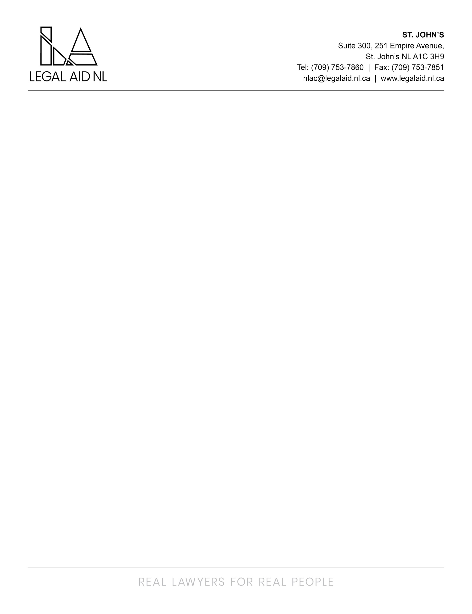

The Newfoundland & Labrador Legal Aid Commission is proud to provide an innovative and collaborative legal aid system that responds to the needs of low-income persons. Our services promote access to justice through the provision of quality legal assistance for criminal, family and some administrative law matters. Legal services are provided through a staff-based delivery model via thirteen full-service offices, four project offices and duty counsel services province wide.

We are currently seeking a full time Manager of Information Services (permanent) to join the team in our Provincial Directors Office based out of St. Johns, NL.

The Manager of Information Services is responsible for planning, recommending, implementing, and managing the information management (IM) programs, policies and procedures of Legal Aid NL. Duties include, but are not limited to:

- Leading strategic IM initiatives and managing the activities of IM staff.
- Oversee and implement policies and procedures to support records management of physical files (paper-based) in Legal Aid offices and electronic files on servers and IT systems.
- Maintaining and updating Legal Aid’s document retention schedules for physical and electronic files.
- Ensuring record storage, retrieval and disposition is completed in compliance with IM polices and the Management of Information Act.
- Ensuring compliance with the privacy provisions of the Access to Information and Protection of Privacy Act (ATIPPA).
- Acting as ATIPP Coordinator for the Commission; processing Access to Information requests and coordinating record searches.
- Liaise with Office of the Chief Information Officer, the Provincial Archives, and Legal Aid personnel in various offices to ensure timely destruction and disposal of records.
- Identify and lead initiatives to transition from physical file storage to electronic file storage.
- Identify training and development opportunities for employees relating to IM best practices, including developing an IM orientation program.
- Leading enhancement to Legal Aid’s electronic client management system to incorporate best practices in IM and management of privacy and confidentiality.
- Completing office administration duties and research projects as assigned.

Education and Experience (Screening Criteria):

- Post-secondary Degree in Information Management or Business or a Diploma in Records and Information Management, or related discipline
- Minimum of 5-years relevant experience
- Experience with the application of electronic document and records management systems
- Experience supervising staff
- Experience with privacy policies and legislation
- Experience with handling access to information requests (asset)
Knowledge, Skills, and Abilities (Assessment Criteria):
- Extensive knowledge of IM practices and procedures
- Proficient in electronic document and records management systems
- Knowledge of information access and privacy policies, practices, and legislation (ATIPP, 2015)
- Policy and program development skills
- Organizational skills
- Ability to work independently
- Ability to think critically
- Ability to communicate effectively

The successful candidate will be required to provide a Certificate of Conduct with Vulnerable Sector Check prior to commencing employment.

Employees of the Newfoundland and Labrador Legal Aid Commission are covered under the Provincial Government’s Pension and Health Plan. Optional Dental and Disability Plans are also available. The salary range for this position is $82,016 to $106,621 (HL-23 on the HAY Pay Scale) per annum.

Interested applicants should send cover letters and resumes to humanresources@legalaid.nl.ca no later than 4:00pm on Wednesday July 15th, 2026.

We thank all applicants for their interest; however, only those selected for an interview will be contacted.

