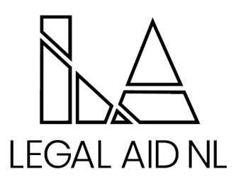

Legal Aid NL is proud to provide an innovative and collaborative legal aid system that responds to the needs of low income persons. Our services promote access to justice through the provision of quality legal assistance for criminal, family and some administrative law matters. Legal services are provided through a staff based delivery model via eleven full service offices, five project offices and duty counsel services province wide.

We are seeking a self-motivated and highly competent individual to fill a permanent Paralegal position in the Happy Valley- Goose Bay Area Office.

Position Summary

The Paralegal will have primary responsibility for developing bail plans, surety confirmation and document drafting. Duties will also include drafting pleadings in family law matters, analyzing and summarizing documents and disclosure, and directed research. Training and mentorship as needed and other related duties as maybe assigned.

Position Qualifications

To be considered for this role applicant must have graduated from an accredited Paralegal Program or have 3-5 years’ experience in a similar role

Knowledge, Skills and Abilities
- Comprehensive knowledge of the Legal Aid Act and Regulations,
- Excellent oral and written communication, negotiation and interpersonal skills
- Ability to exercise sound judgment, diplomacy and tact
- Ability to diffuse conflict situations by utilizing effective conflict resolution skills
- Proficiency in Microsoft applications including Word, Outlook, PowerPoint and Excel

Salary and Benefits

The successful candidate will be required to provide a Certificate of Conduct with Vulnerable Sector Check prior to commencing employment.

Employees of the Newfoundland and Labrador Legal Aid Commission are covered under the Provincial Government’s Pension and Health Plan. Optional Dental and Disability Plans are also available. The salary range for this position is $51,615.20 - $57,330.00 plus Northern Benefits per annum.

Interested applicants should send resume to humanresources@legalaid.nl.ca position will be posted till filled.

We thank all applicants for their interest; however, only those selected for an interview will be contacted.

