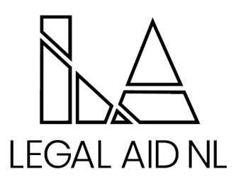

Legal Aid NL is proud to provide an innovative and collaborative legal aid system that responds to the needs of low income persons. Our services promote access to justice through the provision of quality legal assistance for criminal, family and some administrative law matters. Legal services are provided through a staff based delivery model via eleven full service offices, five project offices and duty counsel services province wide.

We are currently seeking a Staff Solicitor to fill one (1) permanent opening in the Gander Area Office.

The successful applicant will have a mixed practice with a wide range of responsibilities including but not limited to: conducting hearings, trials and appeals in the Gander area and in other judicial centers across the province, providing legal opinions and ensuring that legal services are provided in a timely, effective and efficient manner in order to provide the highest level of service to clients.

The successful candidate will hold a Law Degree from a recognized school of law, be a member in good standing or, be able to become, a member in good standing with the Law Society of Newfoundland and Labrador. Five years at the bar is preferred - with experience in both criminal and family law practice. Candidates must have strong verbal and written communication skills, excellent organizational and interpersonal skills, and the ability to handle difficult situations and problem solve as needed. Exceptional accuracy and attention to detail is a must, along with a strong work ethic and the ability to take initiative. Additionally, you must possess a positive attitude, a passion for providing service and high standards of ethics, professionalism and confidentiality and a demonstrated ability to thrive in a fast paced and challenging legal environment.

The successful candidate will be required to provide a Certificate of Conduct with Vulnerable Sector Check prior to commencing employment, as well as a Certificate of Good Standing from the Law Society of which they are a member.

Employees of the Newfoundland and Labrador Legal Aid Commission are covered under the Provincial Government Pension Plan and Health Plan. An optional Dental Plan and Disability Plan are also available. The salary for this position is based on the Solicitor I – IV Pay Scale - $82,061 - $158,719 annually.

Interested applicants should send resumes to humanresources@legalaid.nl.ca no later than 4:00pm on Friday April 17th, 2026.

The successful candidate will be eligible to apply for an Area Director position upon commencement of employment.

We thank all applicants for their interest, however, only those selected for an interview will be contacted. Applicants should note that once the vacancy is filled, a list of qualified candidates will be established and may be used to fill any further vacancies in other Legal Aid NL offices within a 6 month period.

