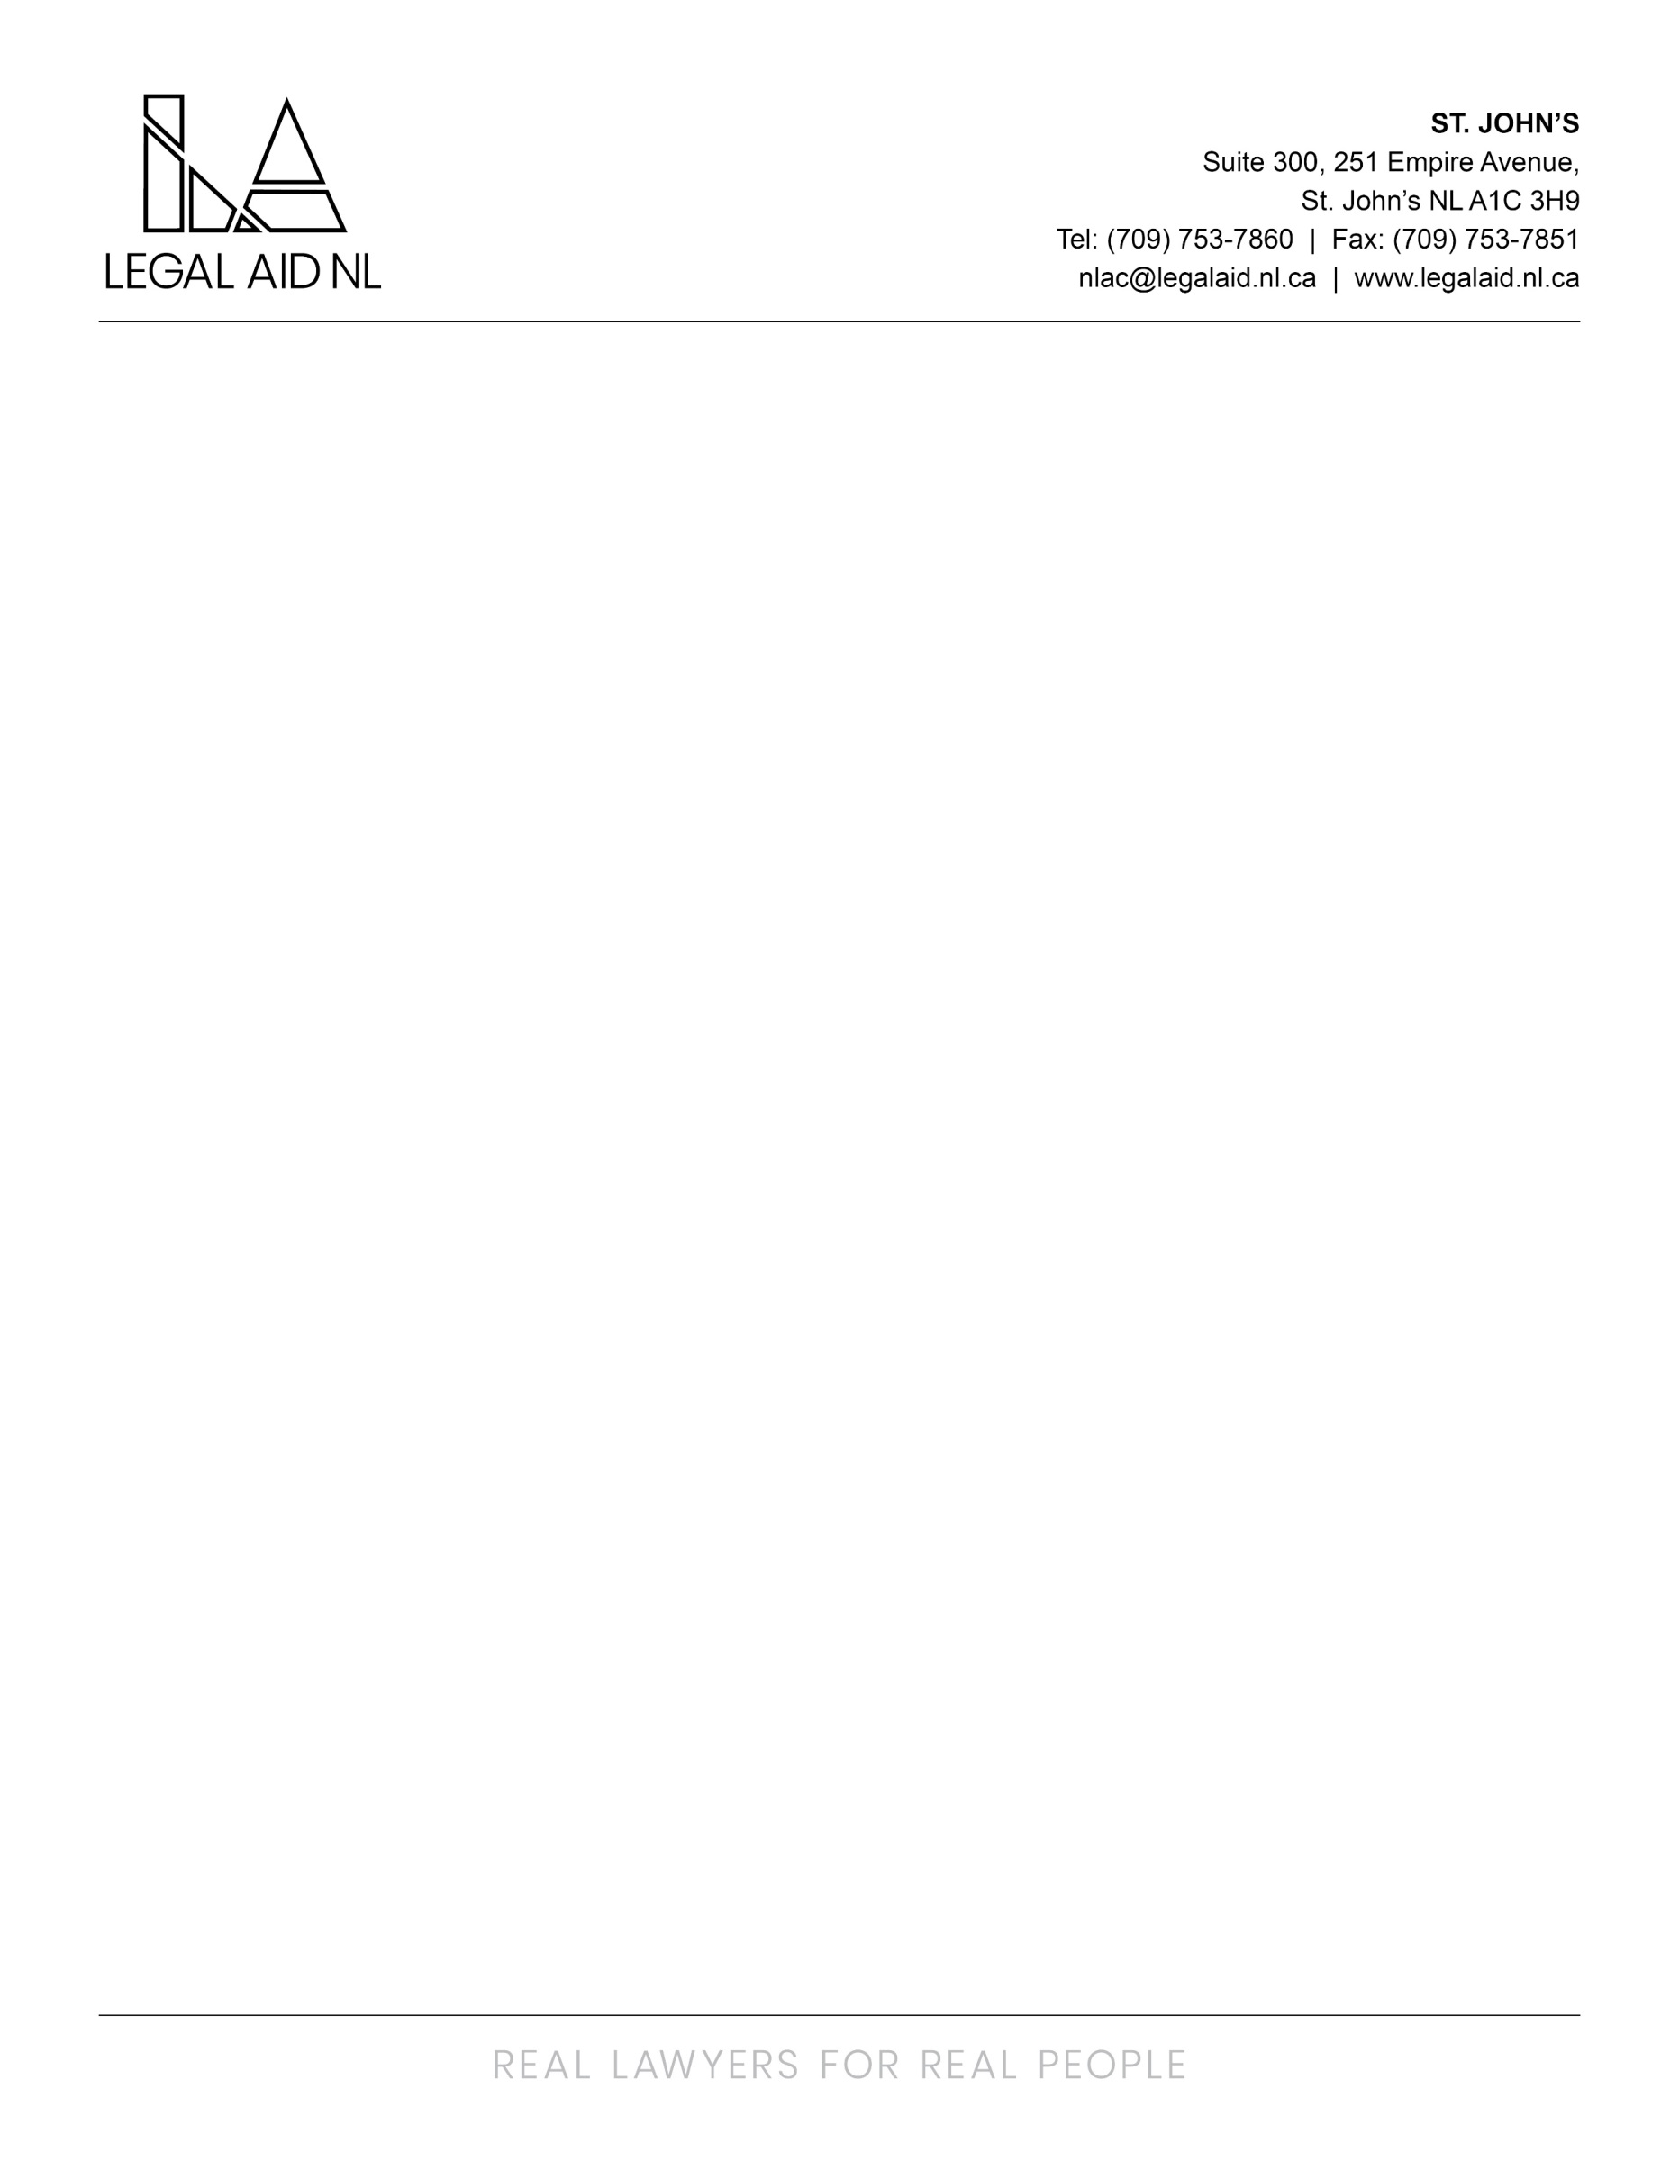

Legal Aid NL is an innovative legal aid plan that responds to the needs of low income persons by promoting access to justice through the provision of quality legal assistance for criminal, family and some administrative law matters. Services are provided through a staff based delivery model via the twelve full service offices and five project offices in the province.

We are currently seeking a Receptionist for a permanent position in the St. John’s Primary Conflict Office. Reporting to the Area Director (or designate), the typical duties of the position include, but are not limited to:

Responsibilities:
- Greeting visitors and directing them to the appropriate personnel
- Operating the switchboard – answering, screening and forwarding calls, taking messages and providing information as required
- Receiving, sorting and preparing mail and courier packages
- Assisting the Intake department in making appointments, setting up files, maintaining filing system
- Maintaining the kitchen, meeting rooms and reception area, including tidying and ordering of supplies
- Other related office duties as assigned

Requirements:
- Ability to work effectively and efficiently in a fast paced office environment
- Excellent written and verbal communication skills
- Diploma in office administration/administrative assistant or at least two or more years’ experience in a similar role
- File management experience
- Proficient in using Microsoft Office, particularly Word and Excel
- Accounting experience would be an asset but not required

Employees of the Newfoundland and Labrador Legal Aid Commission are covered under the Provincial Government Pension Plan and Health Plan. An optional Dental Plan and Disability Plan are also available. The salary range for this position is $39,403.00 to $42,915.60.

The successful candidate will be required to provide a Certificate of Conduct with Vulnerable Sector Check prior to commencing employment.

Interested applicants should send resume to humanresources@legalaid.nl.ca no later than 4pm on Friday March 13th, 2026.

