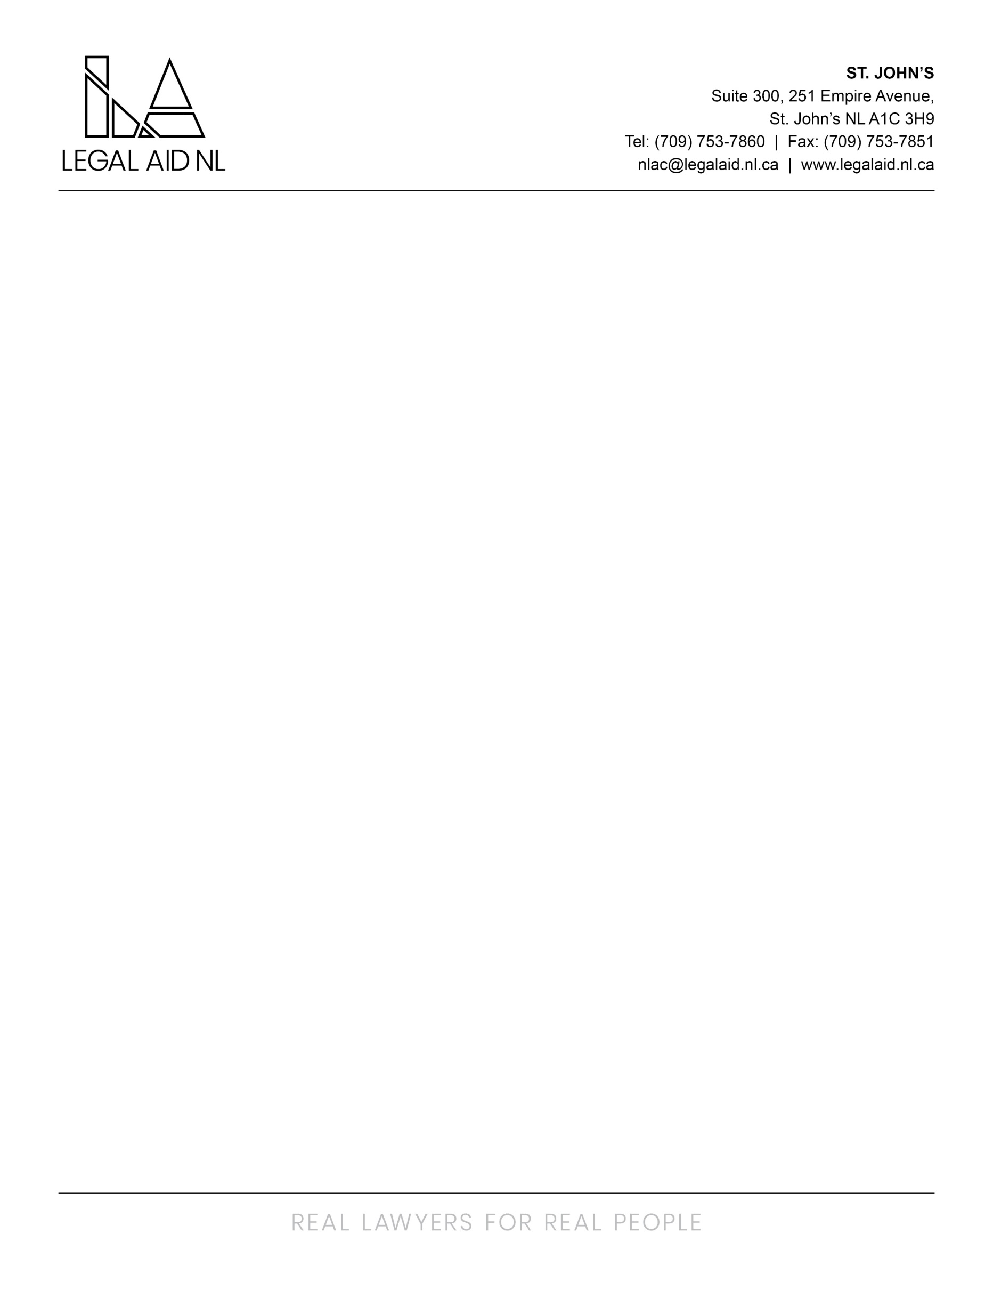

Legal Aid NL is an innovative legal aid plan that responds to the needs of low income persons by promoting access to justice through the provision of quality legal assistance for criminal, family and some administrative law matters. Services are provided through a staff based delivery model via the twelve full service offices and five project offices in the province.

We are currently seeking an Administrative Coordinator to join the Provincial Director’s Office and assist in effectively and efficiently carrying out a variety of operational duties including, but not limited to:

- Provide highly confidential administrative support to the Provincial Director, such as managing incoming/outgoing mail, faxes and phone calls directed to the Provincial Director/CEO, scheduling meetings, booking travel, edit/draft documents as needed.
- Coordinate and schedule meetings for Management Committee and Board of Directors. The incumbent will attend and record decisions at committee meetings; track follow-up action items; prepare agendas, minutes, appeal packages and other materials as required.
- Assist with building management for all Legal Aid NL offices across the province. This includes coordinating with landlords and staff to address recurring and/or urgent repair and maintenance issues, as well as compliance with lease terms and conditions.
- Manage building access for employees and contractors using proprietary software including programming, locking doors, setting up holidays, and troubleshooting.
- Act as primary point of contact for after-hours inquiries relating to alarm monitoring and security.
- Identify and review requests relating to furniture and equipment for all Legal Aid NL offices. Coordinate delivery, installation, returns, and disposal of equipment/furniture as required.
- Assist the Provincial Director/CEO as needed with respect to lease renewals and tendering for office space and storage spaces for the Commission.
- Assist the Provincial Director/CEO with preparation of reports, presentations, and other strategic documents as required.
- Assist with planning and logistics related to the Annual General Meeting (AGM), and update Legal Aid NL’s website and intranet as required.
- Provide back-up administrative duties to other support positions within the Provincial Director’s Office when required.
- Assist with knowledge sharing, mentoring and training of co-workers and new employees as requested
- Perform other administrative tasks, duties, and projects as assigned.
Screening Criteria:
- Administrative Diploma, or Legal/Administrative Assistant Diploma (or equivalent)
- Minimum of 5 years’ experience in an administrative role
- Experience in the legal field is considered an asset.

Assessment Criteria
- Strong analytical, communication, and interpersonal skills
- Ability to conduct research and create reports and presentations
- Ability to manage multitask and manage time effectively
- Exceptional accuracy and attention to detail
- Strong work ethic and initiative.
- High standards of ethics and professionalism
- Intermediate to advanced proficiency in Microsoft Office

This is a permanent position based in St. John’s. Travel within the province to Area Offices and Project Offices may be required. The successful candidate will be required to provide a Certificate of Conduct with Vulnerable Sector Check prior to commencing employment.

Employees of Legal Aid NL are covered under the Provincial Government Pension Plan and Health Plan. An optional Dental Plan and Disability Plan are also available. The salary ranges from $51,908 to $67,481 annually and is based on the HAY Management Pay scale (Hay Level 13)

Interested applicants should apply via (humanresources@legalaid.nl.ca) no later than 4:00pm on Wednesday, March 18, 2026.

We thank all applicants for their interest, however, only those selected for an interview will be contacted. Applicants may be considered for similar openings that arise within 6 months of the closing date.

