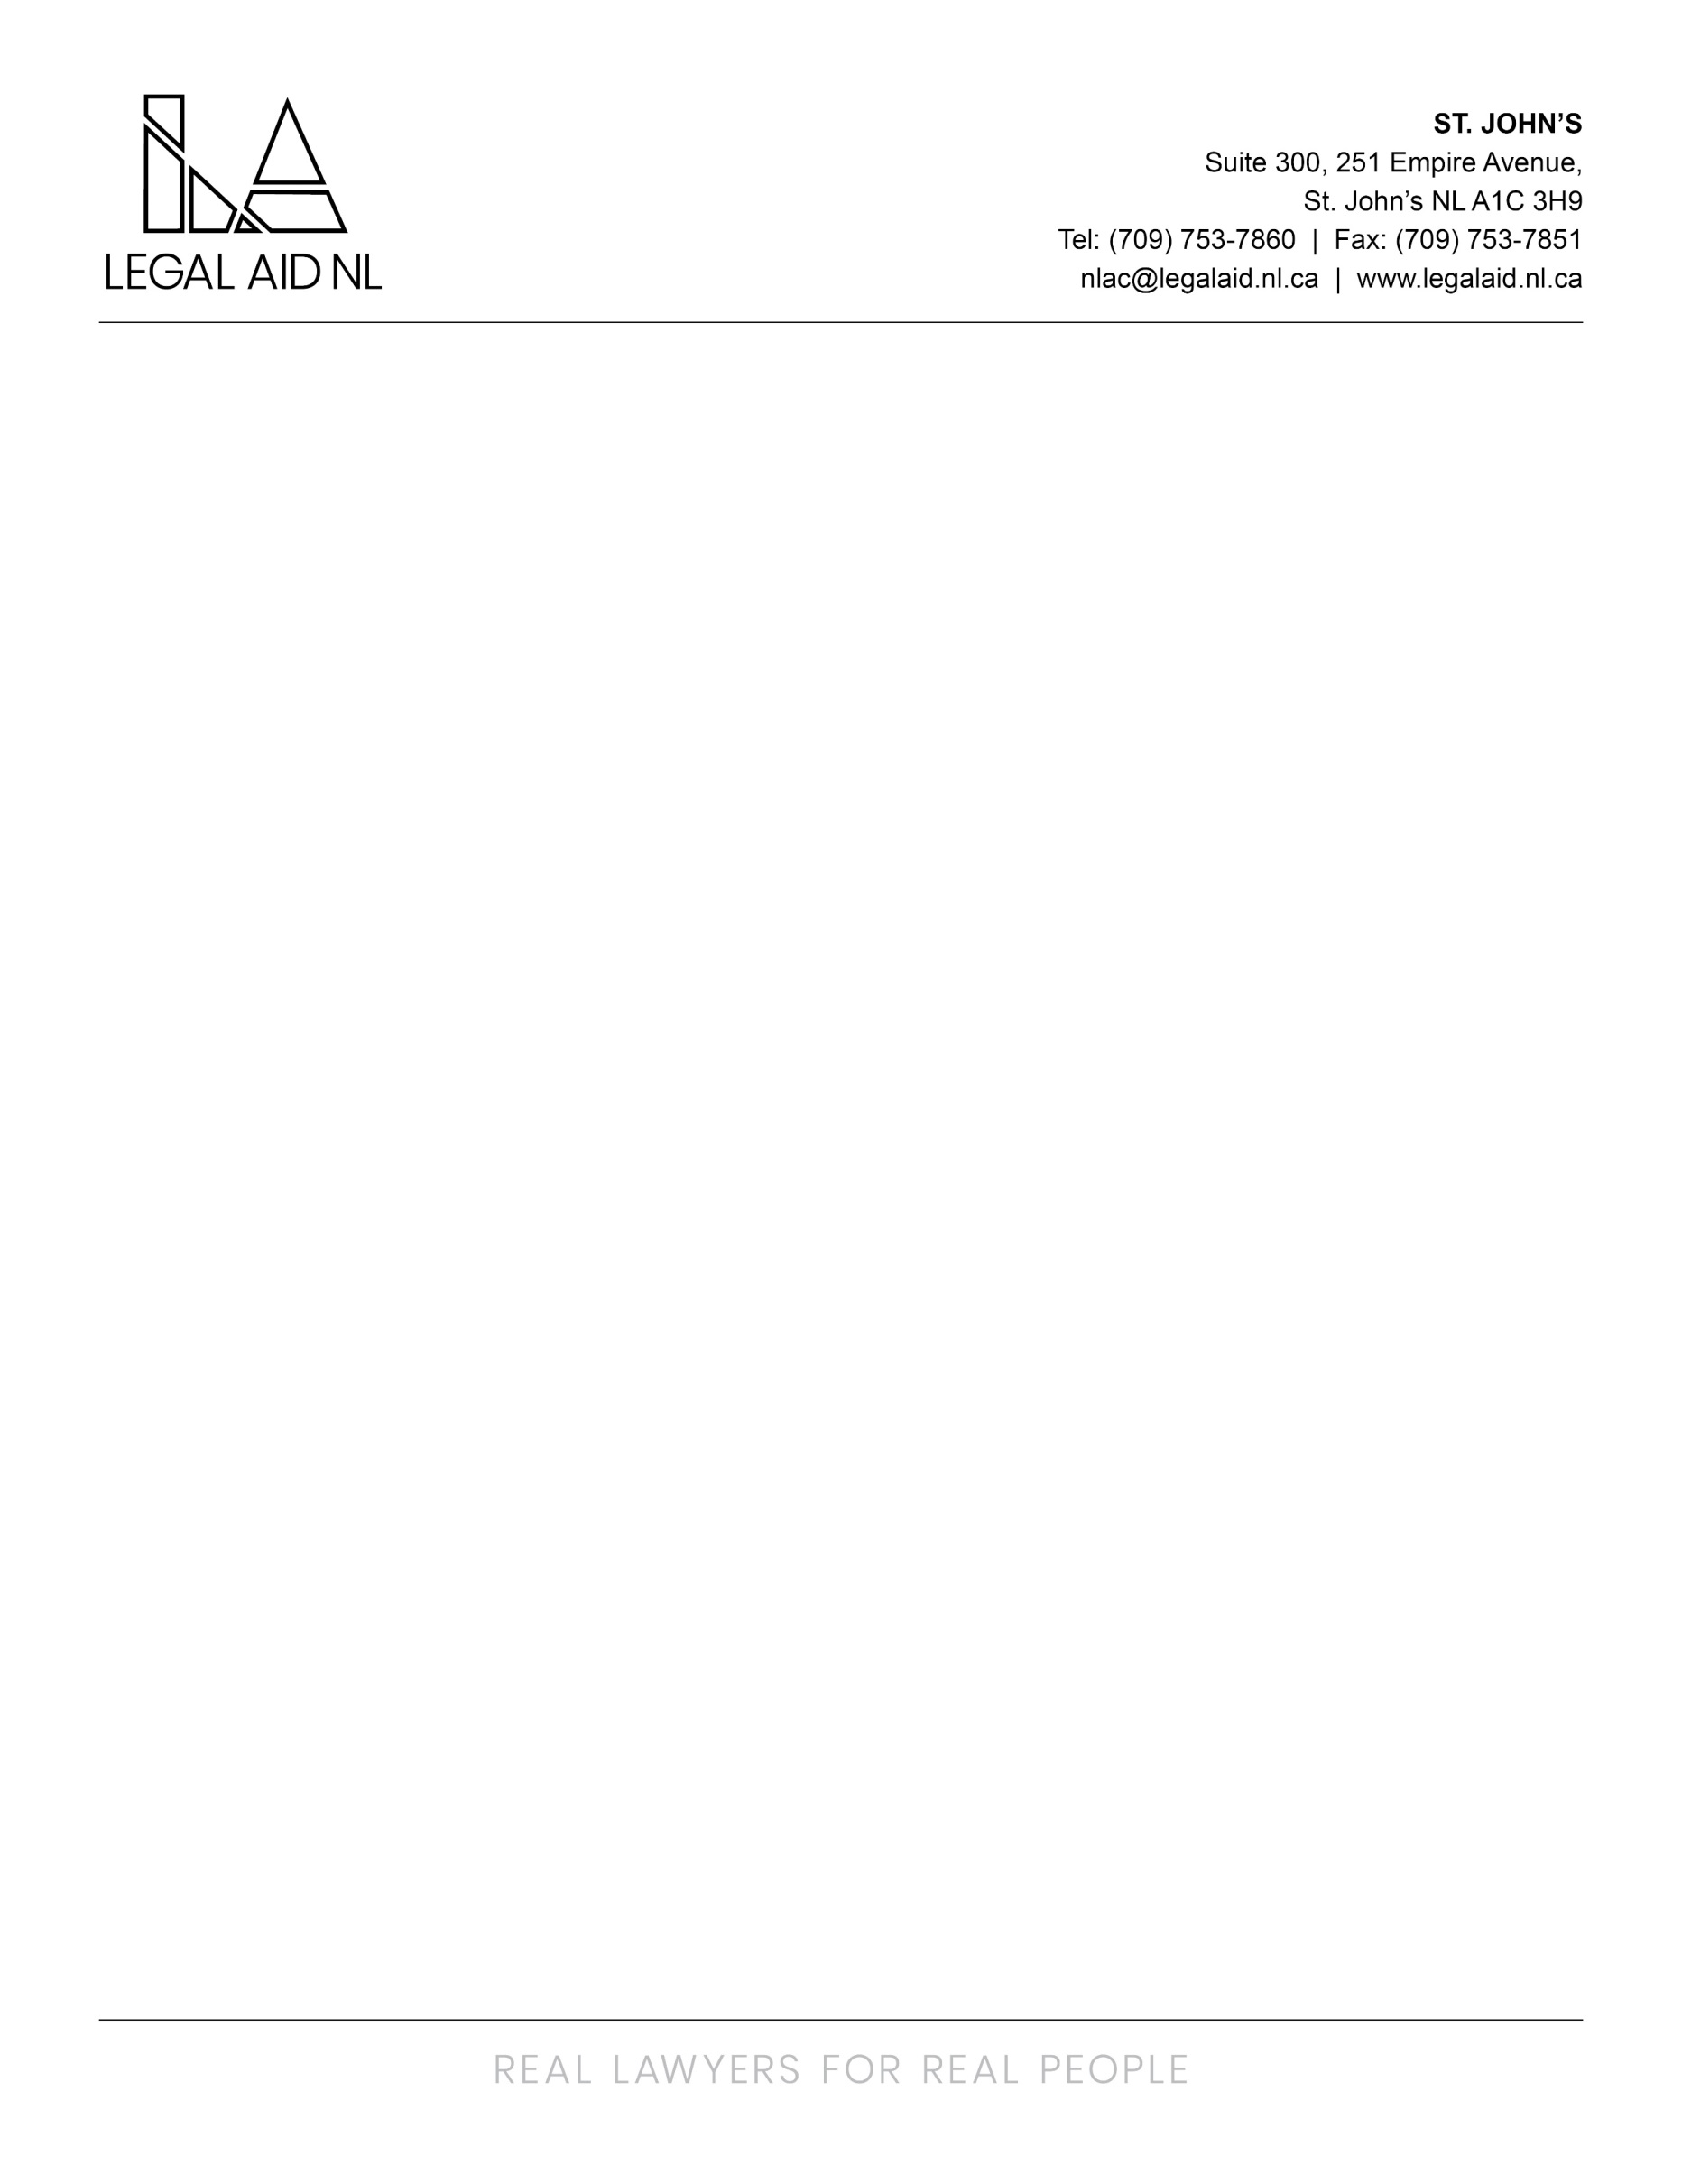

Legal Aid NL is searching for Staff Solicitors to fill contractual and permanent roles in the following area offices:

Happy Valley-Goose Bay (Labrador) Area Office
Gander Area Office

Solicitors will have a mixed family/criminal practice including but not limited to: conducting hearings, trials and appeals in the jurisdiction of their home office, as well as circuits to communities in Labrador and judicial centers across the province.

Successful candidates will hold a Law Degree from a recognized school of law, be members in good standing or, be able to become, members in good standing with the Law Society of Newfoundland and Labrador. While five years at the bar is preferred, articling students with June 2025 bar call dates will be considered.

Successful candidates will be required to provide a Certificate of Conduct with Vulnerable Sector Check prior to commencing employment as well as a Certificate of Good Standing from the Law Society for which they are a member.

Salary range for these positions is $82,061 - $158,719. Legal Aid NL employees based out of Labrador are eligible to receive generous Northern benefits, including a travel and living allowance. In addition, Labrador based Staff Solicitors also receive an annual financial incentive of up to $25,000 (pro-rated) in addition to their base pay; reviewed annually on April 1 of each fiscal year. Staff participate in the Newfoundland and Labrador Provincial Government’s Pension and Benefits Plans. Relocation assistance will be considered.

Cover letters/resumes should be sent to humanresources@legalaid.nl.ca, positions will be posted until filled.

